MACHINE PROBLEM

PYTHON SOLUTION PROBLEM # 3

Aguinaldo, Kurt 2ECE – A

Sales, Ace Lawrence

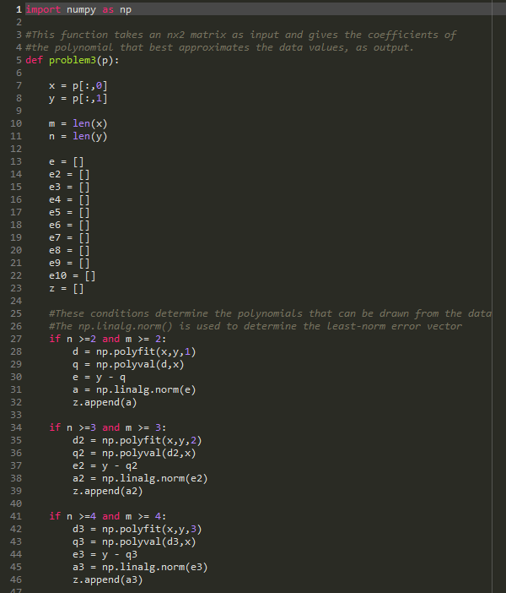**SCRIPT FILE:**

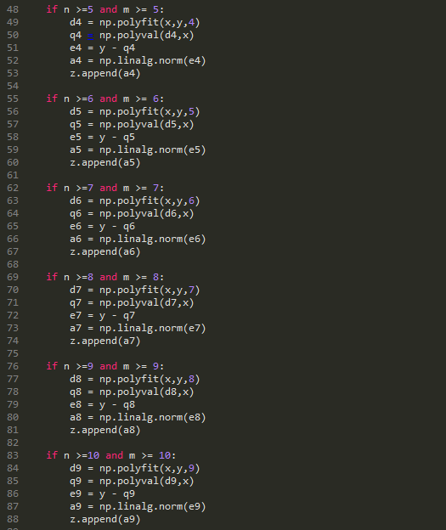

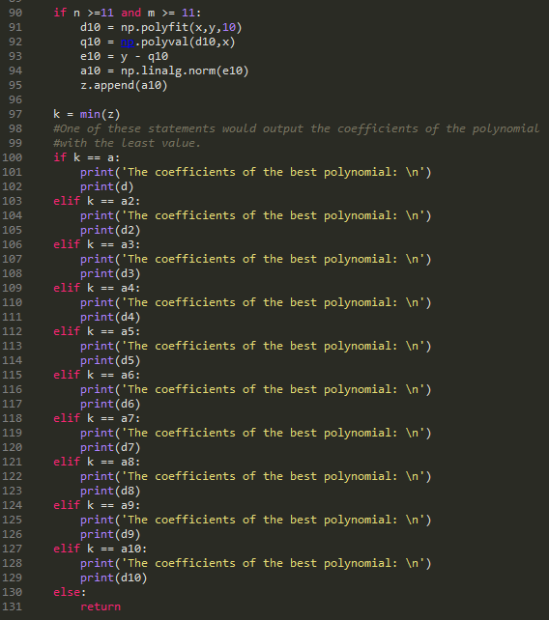

Using input problem3(np.array([(-3, 174), (-2,41), (-1,4), (0,0), (1,-7), (2,-29), (3, -52), (4, -41), (5, 60)]))

**OUTPUT:**

